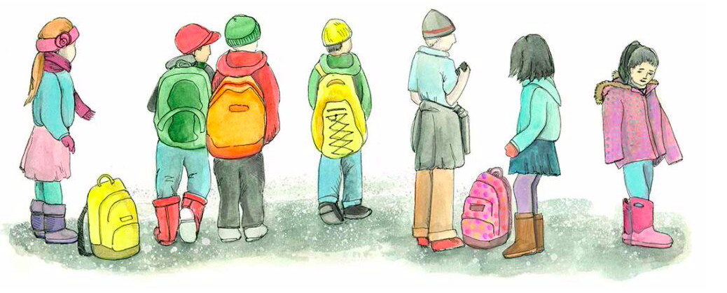

Transforming Schools: A Suite of Resources for Trauma-Engaged Practice in Alaska

The vision of the Transforming Schools suite of resources is to help Alaska schools and communities integrate trauma-engaged practices and policies into their everyday activities. Improving student outcomes means supporting the whole child, and understanding how trauma impacts a child’s ability to learn and thrive. Transforming Schools offers a framework, toolkit, video library, e-modules, videos and milestone guides. These resources provide information for reading, reflecting, moving into action, and seeing examples of practice.

The Trauma Engaged Schools Framework (print versions available) provides stories, reflection questions, and research to support each of the 11 sections. This is the best resource to read for grounding yourself or your team. https://education.alaska.gov/tls/safeschools/pdf/transforming-schools.pdf

The Trauma Engaged Toolkit (online resource) offers Alaska schools and communities ways to integrate trauma-engaged practices and policies into their everyday activities in order to improve academic outcomes and well-being for all students. The tools are compiled from national and statewide resources and support action steps for school leaders, school staff, health workers, and school boards. https://education.alaska.gov/apps/traumawebtoolkit/landing.html

Trauma Engaged Video Library (online resource in each section of the Toolkit) offers over 50 peer-led and statewide experts short videos tied to the topics in the Framework. They are under 10 minutes and easily accessible for personal review or in a group setting to stimulate discussion.
https://education.alaska.gov/apps/traumawebtoolkit/landing.html

Trauma Engaged Milestone Guides (templates available online in each section of the Toolkit) provides steps to deepen personal growth, establish a common vision with colleagues and community. There is a guide for each of the 11 components in the Transforming Schools framework.
https://education.alaska.gov/apps/traumawebtoolkit/landing.html

Trauma-Engaged DEED eLearning Modules (online resources on the Framework website) offer 12 self-paced courses for school staff and community members to explore both underlying information important to doing trauma engaged work as well as many practical activities and lessons for school staff to use. These may be used in a group setting as well.
https://education.alaska.gov/apps/traumawebtoolkit/new-framework-page.html

Trauma-Engaged Professional Development Series (online resources on the Framework website) offers 11 webinars hosted by AASB and DEED featuring district and school presenters speaking to one of the 11 Transforming Schools components. These webinars are available for individual or group viewing.
https://education.alaska.gov/apps/traumawebtoolkit/new-framework-page.html

Additional Resources:
There are additional on-going statewide opportunities to share and learn from peers, principals, district, or school staff dedicated to embedding trauma engaged schools.

Alaska Healthy Schools Learning Collaborative (virtual learning opportunities)
covers a broad range of school health and wellness topics for school staff, including Mental Health, Staff Wellness, School Health, Trauma-Engaged Practice, Social Emotional Learning/Relationship skill building and more.
https://education.alaska.gov/safeschools/alaska-healthy-schools-learning-collaborative

SEL-Trauma Engaged Professional Learning Community (PLC) (online learning community) is a statewide learning community hosted on Alaska Staff Development Network’s AkPLN platform, which is connected to the Teaching Channel. Joining the Alaska SEL-Trauma Engaged PLC is free. AASB can design a personalized trauma engaged PLC for your district or school (fee).
AkPLN https://asdn.org/akpln/
AASB https://aasb.org/trauma-engaged-services/

Personalized Consultation (AASB (fee) or DEED) is available to support using the Transforming Schools suite of resources for planning, professional learning, and monitoring progress in your district or school. Contact AASB or DEED for more information.
AASB https://aasb.org/trauma-engaged-services/
DEED https://education.alaska.gov/apps/traumawebtoolkit/new-framework-page.html

